School Improvement Plan 2022-2023

Our School Improvement Plan 2022-2023 is underpinned by our vison of ‘Together We can Make a Difference.’ All stakeholders work together on these key priorities to make a difference to all the children in our care. This SIP is built on: information from school’s data, outcomes and effective research as explained in the Education Endowment Fund document ‘Moving Forwards, Together we can make a difference ‘and outcomes from our Governor review meeting.
We aim to ensure that the school improves learning for all embracing recent research, targets learning for the most vulnerable groups in the school and continues to embed wider strategies that will benefit all.
The strands of this SIP are explicitly linked to the SIAMS strands linking our school improvement plan to our Church School Ethos ‘Learning with Hope’ in the context of school improvement means strong quality first teaching with a bespoke inclusive curriculum being delivered within a nurturing and supporting learning environment where children build courage and perseverance to be the best learners they can be and live ‘life in its fulness’.

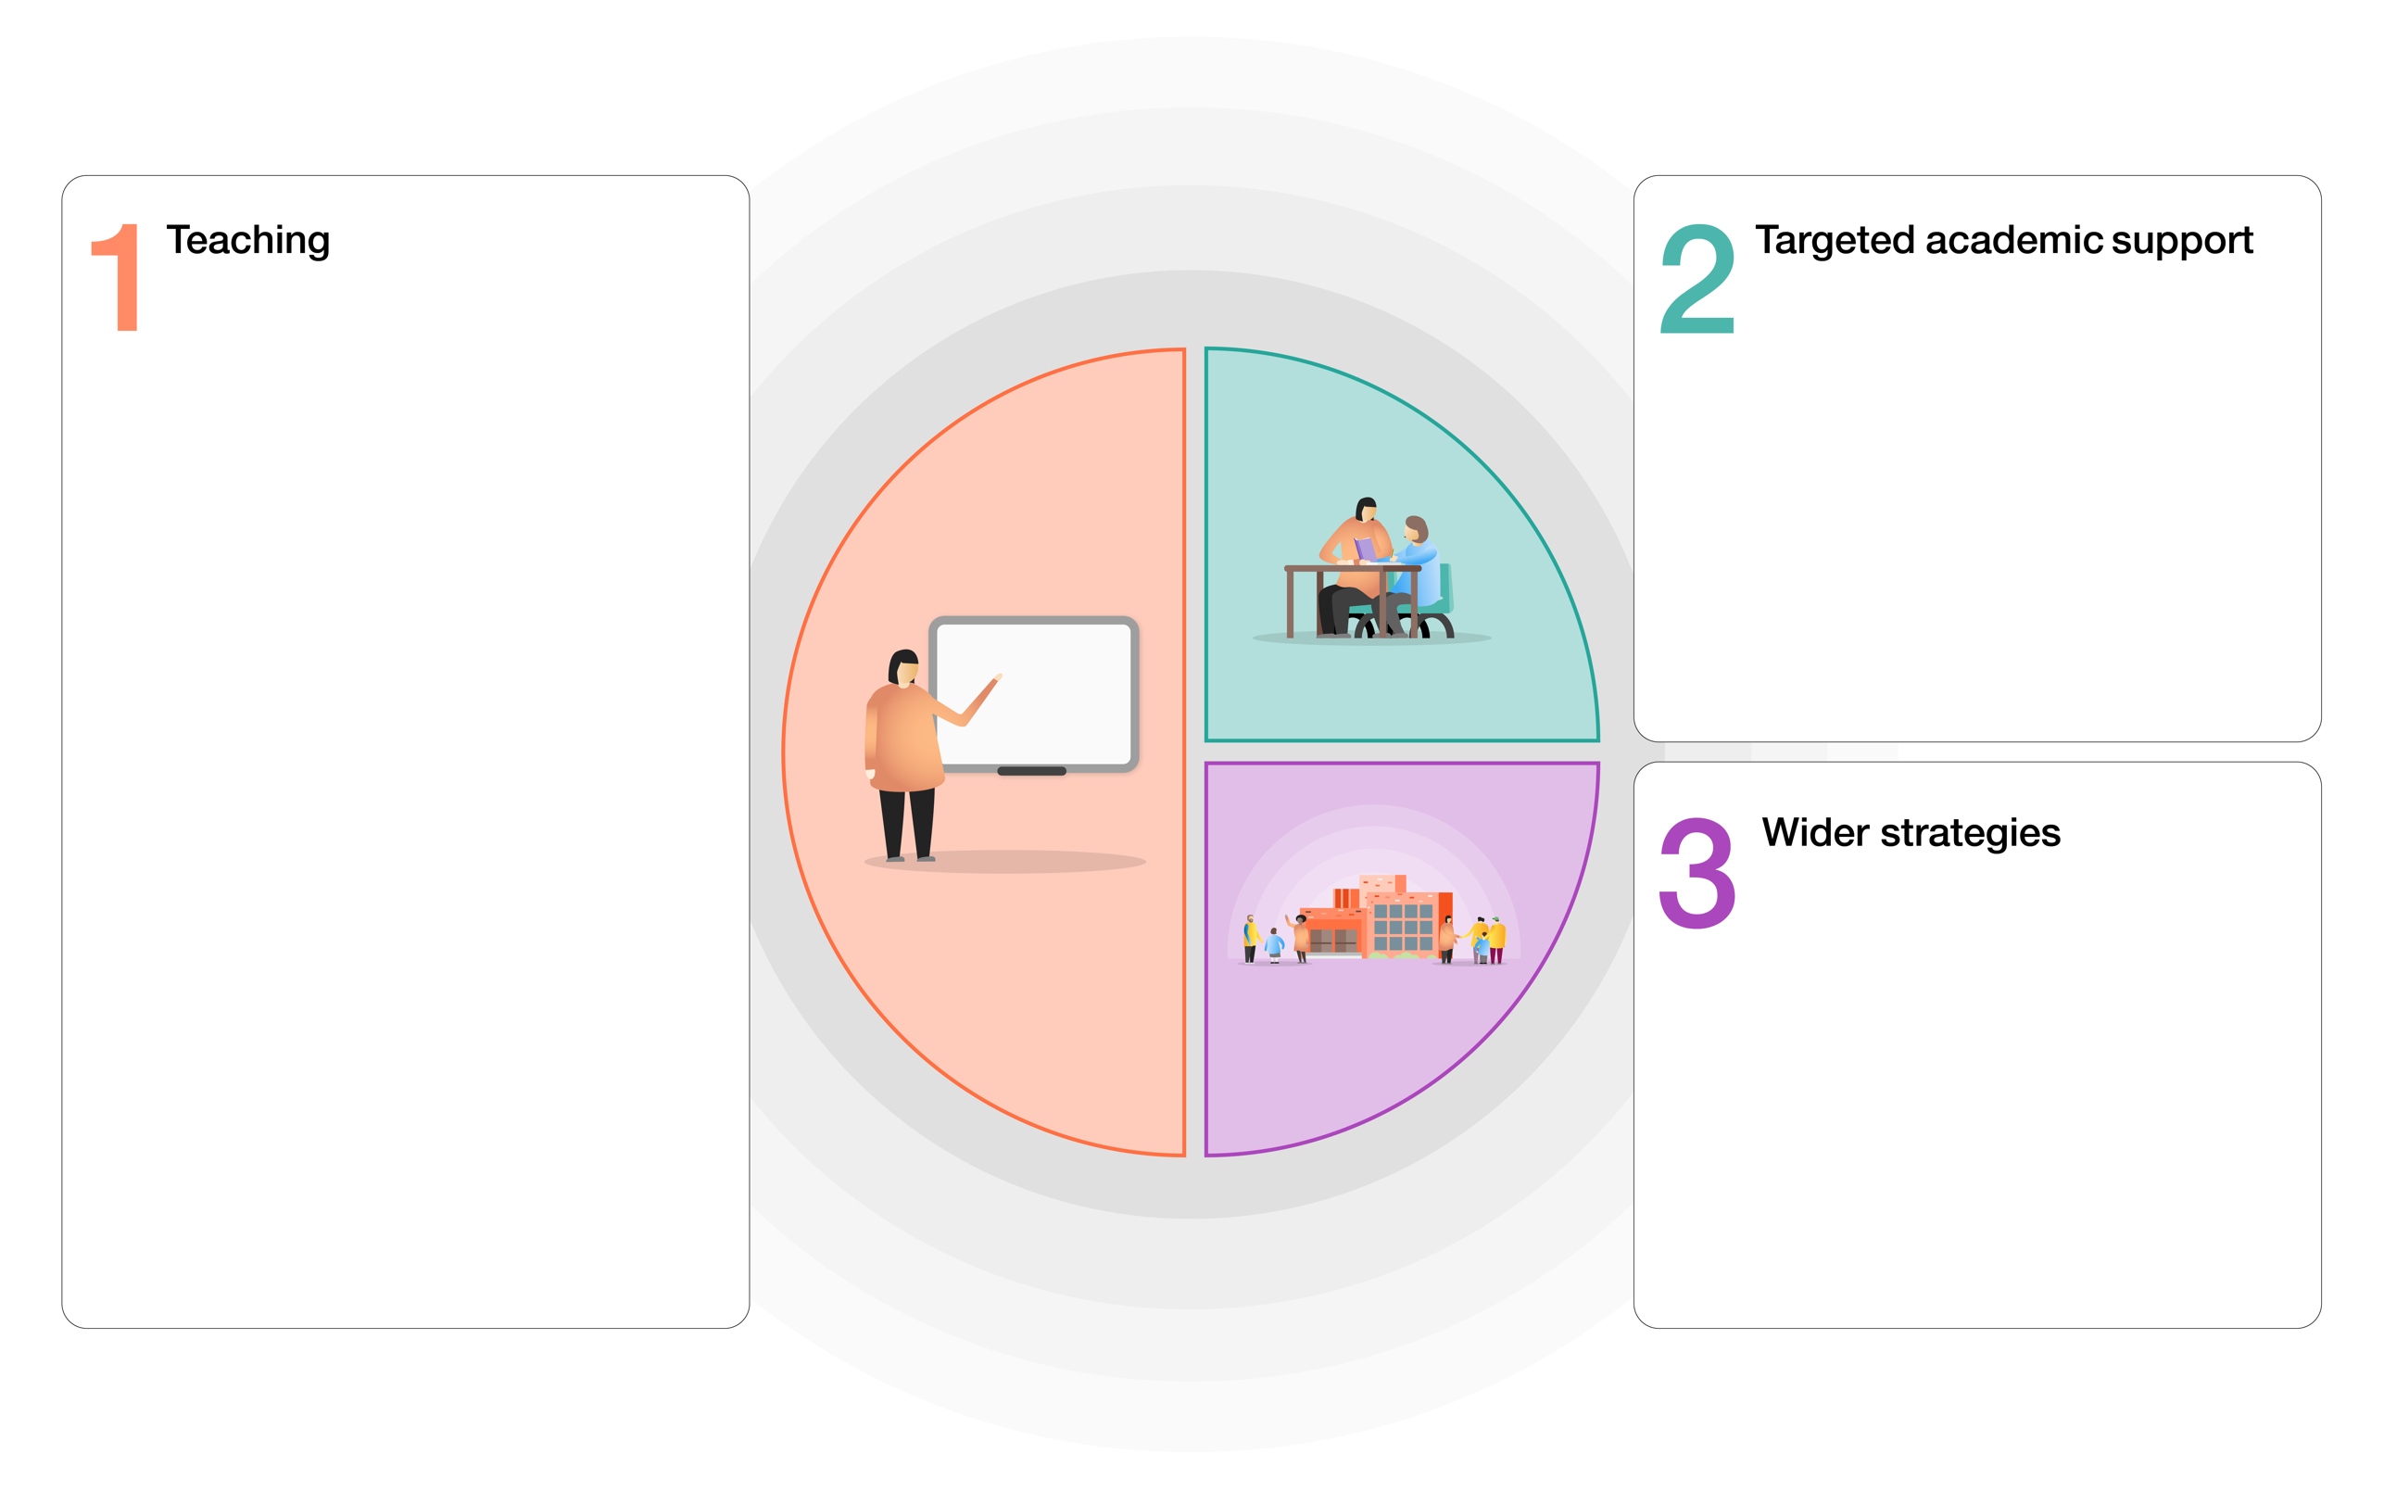

SIAMS specific and underpinning ethos
Strand 1: Vision and Leadership
Strand 6: The impact of collective worship
Strand 7: The effectiveness of religious education

High supported by high quality structured and targeted interventions securing good progress to diminish progress gaps..
- Effective well researched intervention strategies are used and monitored rigorously
Strand 5: Dignity and Respect

Ensuring high quality first teaching across the school leading to improved outcomes for all pupils.
SIAMS strand link
Strand 2: Wisdom, Knowledge and Skills
Strand 3: Character Development: Hope, Aspiration and Courageous Advocacy
Strand 5: Dignity and Respect
- High quality teaching is the key to success for all children.
- Adoption of 5 a day approach to focus on aspects of effective teaching,
- Effective use of diagnostic assessment to move learning forward
- Develop oracy across the curriculum
- Embed early reading approaches with Little Wandle
- New approach to writing – The Write Stuff
- Ensure consistent approaches to maths across the school
- Embedding assessment across the curriculum
- All subject are inclusive of children with additional needs

Children’s wellbeing Addressing children’s social and emotional needs
- Develop Children mental health policy with stage approach to proactively addressing children’s social and emotional needs
- Continue to develop and improve communication with parents and carers working in partnership to support children’s learning
Strand 3: Character Development: Hope, Aspiration and Courageous Advocacy
Strand 4: Community and Living Well Together
Strand 5: Dignity and Respect

quality teaching is
Children well being – Addressing children’s social and emotional needs
- Develop children’s mental health policy with staged approach to proactively addressing children’s social and emotional needs.
- Continuing to develop and improve communication with parents and carers to support children’s learning
Strand 3 – Character Development – Hope, Aspiration and Courageous Advocacy
Strand 4 – Community and Living well together
Strand 5: Dignity and Respect

- Teaching

High Quality Teaching

- To increase the percentage of KS1 children reaching the expected level in Reading, Writing and Maths to be in line or above the national average.
- To increase the percentage of KS2 children reaching the expected level in Reading, Writing and Maths to be in line or above the national average.
To improve the quality first teaching by embedding the 5 a day approach.

Action points | Action by | Cost | Success Criteria/Outcome | Review March 2023
Embed the ‘5 a day’ approach in staff meetings and with support staff  Focus  - Explicit instruction  - Cognition and metacognition  - Scaffolding  - Flexible grouping  - Using technology  Staff meeting time to introduce this,  Specific staff meeting on metacognition to upskill all staff on this, | HT/JS | Overtime for support staff | All teacher staff are embedding the principles in the daily teaching.  Lesson planning shows evidence of the 5 a day approach.  Learn walks show approaches are embedded  Progress data improved  Children can articulate how they learn in pupil conferencing.  All support staff are embedding the principles in the daily teaching.  Learn walks show approaches are embedded  Children can articulate how they learn in pupil conferencing.
New teaching and learning policy to reflect 5 a day pedagogy | HT | n/a | Teaching and Learning policy reflects school’s approach for high quality teaching using 5 a day principle.
Using diagnostic assessments

Action points | Action by | Cost | Success Criteria/Outcome
Use the using diagnostic question for reflection with all staff to benchmark where the school is with assessment | JS/HT staff meeting 28th  November | n/a | Whole school understanding of diagnostic assessment which will inform new teaching and learning assessment policy
New Marking policy to be adapted to support new approaches in English | HT staff meeting 10th October | n/a | New Marking policy adopted bv all and evidence of this being effectively applied in practise.
Introduce BSquared to all teacher for diagnostic assessments of children with need | JS Autumn term 2022 | Subscription to B squared  PP funding | Full use made of B squared by teachers to help assess children on School Support and identify small steps progress.
Improving Outcomes in English
- To develop oracy across the curriculum, leading to improved outcomes for all children.
- To embed Little Wandle across EYFs and Ks1 ensuring improvement in reading attainment in Year 1 and Year 2.
- To adopt the little Wandle KS2 phonics catch up programme to support pupils in KS2
- To adopt the Write stuff approach to writing across the school to improve writing standards across the school.
- To adopt new Spelling scheme across the school to improve writing standards across the school
Action points | Action by | Cost | Success Criteria/Outcome | Review

Oracy
‘Oracy Displays’ added to every classroom including stem sentences and sentence starter prompts. | All staff. EH to monitor. | N/A | ‘Oracy Displays’ evidenced in every classroom. EH to monitor.
‘Word Of The Day’ integrated by every class by the end of the Autumn Term 2022. | All staff. EH to monitor. | N/A | ‘Word Of The Day’ evidenced in every classroom. Encourage children to use these words at least once a day in their work. EH to monitor.
‘Quote Of The Day’ integrated by every class by the end of the Autumn Term 2022. | All staff. EH to monitor. | N/A | ‘Quote Of The Day’ evidenced in every classroom. EH to monitor.
New ‘Jane Considine Literacy Scheme’ integrated to increase vocabulary. | All staff. EH to monitor. | N/A | Increased vocabulary evidenced through Literacy Books, Literacy assessments, etc. Staff meeting time allocated to monitor this.
Increased emphasis of the importance for full sentences in ALL subjects using stem sentences and sentence starter prompts to support this. | All staff. EH to monitor. | N/A | Evidence to be monitored through learning walks. All subject leaders to monitor. Staff meeting time allocated to monitor this.  Pupil conferencing in all subject shows this.

Reading
High quality phonics teaching Little Wandle, is securely embedded effectively across EYFS and KS1 | LH and class teacher | Annual subscription costs | Teachers and support staff new to KS1 are confident with LW and effective in teaching this approach.  Increasing number of pupil finish LW by end of Year 1 and are succeeding at reading
Little Wandle is used as the default catch up for reading in Year 3 and 4 | LH/JS class teachers support staff | Cost of catch up set  £1,000 for resources | Learning walks show learning in catch up session is good  Effective catch-up session running using LW in Year 3 and 4
Reading for Pleasure strategies developed to improve reading outcomes aiming to make children readers for life (see subject action plan) | LH to coordinate - All staff to impliemnt | £500 contribution towards author visits form FOSMs | Children are able to articulate enjoyment of reading.  Improved outcomes in reading attainment KS1 and KS2.

Writing
Implement adoption of The Write Stuff approach to Writing across –see detail action plan | AG/NB/HT  All staff | £2,500 | Improvement in writing outcomes across the school in both progress and attainment.  Improvement in attitudes to writing across the school.
Implement adoption of The Spelling book approach to Spelling across –see detail action plan | AG/NM/HT  All staff | £500 | Spelling outcomes improving for all across the school

Improving Outcomes in Maths

To improve progress for ALL children in maths across the school
Action points | Action by | Cost | Success Criteria/Outcome
Staff meetings to be planned throughout the year to focus on each of the five areas of mastery (representation and structure, variation, fluency, mathematical thinking and coherence.) Each staff meeting to have a focus on extending greater depth children.  Opportunities for EH and MD to see quality first teaching of maths at St Mary’s | JS | Overtime costs for HLTA | Quality first teaching of math improves across the school  All children making at least good progress
In the representation and structure staff meeting we will review and adjust policy to make it an effective working document. New staff to gain a greater understanding of policy. | JS | Overtime costs for HLTA | Staff subject knowledge improved leading to better QFT and outcomes for children
Learning walks across the school show that lesson structure and maths policy is being followed consistently | All staff  JS | Supply cost JS from St Mary’s | Improved consistency of approach to Maths across the school

Curriculum
Assessment across Foundation subject  Effective assessment is embedded in all subjects and being used to inform future teacher | All staff |  | Assessment in place for all subjects across the curriculum and informing teaching
Subject leadership  All subject action plans focus on progress for all children with specific strategies for SEN in place to ensure all children make good progress across the curriculum | All staff |  | All children accessing all subject effectively and making good progress
All subject show small steps learning in place for all subjects | All staff | 3 days release time across the school for Subject leads and dedicated staff meeting time | All curriculum subjects have clear small steps learning in place which builds on previous learning from EYFS- Year 6

Targeted Academic Support
Action points  For more detail on provision for SEN see SEN action plan for 2022-23. | Action by | Cost | Success Criteria/Outcome | Review
EYFS  Phonics and Maths catch up as needed AG to arrange | AG/JS |  | Improve rates of progress for all children involved
KS1  Ensure effective intervention for reading are in place – Little Wandle Catch up | LH  EYFS and KS1 staff | n/a | More children in Year 2 and Year 2 on track to complete Little Wandle by Year 2
KS2  Ensure effective intervention for reading are in place –  Little Wandle Rapid Catch up/SEN for children in who still need phonics approach  Reading catch up children who need further practise in comprehension strategies | JS  All staff | Little Wandle Catch up resources  SEN resources | Improved reading outcomes for children in Year 3 and 4 not yet reaching expected level
KS1 and KS2 Maths  Ensure effective intervention for maths for children needing catch up, | Class teachers | Supply costs for pre teaching groups one afternoon a week  (catch up and school led tutoring grant) | All children making good progress in maths and children just below make accelerated progress to meet expected standard
Use effective diagnostic assessment to ensure effective personalised strategies are being used for children needing learning broken down into small steps progress | JS  All staff | B squared assessment | Children on RON making accelerated progress against personalised targets
Ensure all ‘additional to’ or ‘different from’ provision for EHCPS or School Support is effective, meeting learning needs and building personalised small steps progress | JS  All staff |  | Children on RON making accelerated progress against personalised targets
Ensure all subject leaders know strategies to support children with SEN in their subject area and effective provision is in place for all children to make good progress across the curriculum | All subject leaders | Subject leader time – staff meetings | Children on RON making good progression all areas of the curriculum

Wider Strategies

Social and emotional health.
Action points | Action by | Cost | Success Criteria/Outcome | Review
Audit of well-being across school community Autumn 2022 | All staff | n/a | Survey complete and informing actions
Children’s Mental Health and Well being policy complete, shared with staff and all stakeholders  Policy to include quality first teaching strategies that are universally used across the school, and intervention strategies for children with more acute need. | HT/PT | n/a | Children mental health and well-being policy shared with all stakeholders and implemented
Whole school TIS updates to ensure all staff understand this approach at a whole school level | PT | Possible cost | Whole school joint understanding of working as a TIS school

Parent and carer engagement
Invite parent carers to information evenings about learning during the year  - Class Meetings – September  - New reception Little Wandle Reading meeting -Autumn term  - New Spelling approaches  - Resilience workshop | HT  JS subject leaders | £100 | Increased engagement in children’s learning  Improved attendance
Building community Continued work on ensuring there are community opportunities offered to parents and children:  - Feast for Families @ St John’s every Friday | HT liaise with Rev Sian and Cluster Family workers | N/a | Increased engagement in children’s learning  Improved well being for families

