
ST MARY’S CHURCH OF ENGLAND PRIMARY SCHOOL
Redinnick Place, Penzance, Cornwall TR18 4HP
Telephone/Fax: 01736 363009
Email: head@st-marys-ce-pz.cornwall.sch.uk
Website: www.st-marys.eschools.co.uk
Head teacher: Mrs Hilary Tyreman

Dear Parent/Carer,
Welcome to the new academic year! Your child is about to embark upon an exciting new stage in their education and we are very much looking forward to working with and teaching them this year.
Having moved into a higher year group, they have been made aware that this will involve an increased level of learning, responsibility and participation. We will be calling upon them to undertake extra work at home, much of which will be Internet based.
You will be aware the Internet hosts many exciting opportunities for education. The online world is a wonderful place for young people to explore, with unprecedented opportunities for learning and creativity, but just like the real world there are risks and dangers they should be aware of and which we should all act to protect them from. As a school we encourage the use of technology as an important part of our students’ development but always want them to spend their time online safely. As a parent/carer you can play a significant part in ensuring this.
Just a few simple steps can help you keep them safe and give young people the awareness to know what to do if they feel uncomfortable about anything they encounter while on the Internet.
If you do not wish for your child to be able to access any inappropriate content online, please ensure that their computers, laptops and other devices with internet access are all fitted with parental controls.
On our school website www.st-marys.eschools.co.uk you will find video guides for setting up free parental controls from the 4 big internet providers in the UK – BT, Sky, TalkTalk and Virgin Media.
As a minimum, please set parental controls on your search engines, youtube account and the mobile phone your child uses.
One of the most popular search engines in the world is Google. You can visit Google’s informative safety centre for simple step by step guides - http://www.google.com/familysafety/tools
Here are a few options available to you; they truly are simple to set.
Visit the Google home page – www.google.co.uk and click on the ‘search setting’ tab in the top right hand corner.

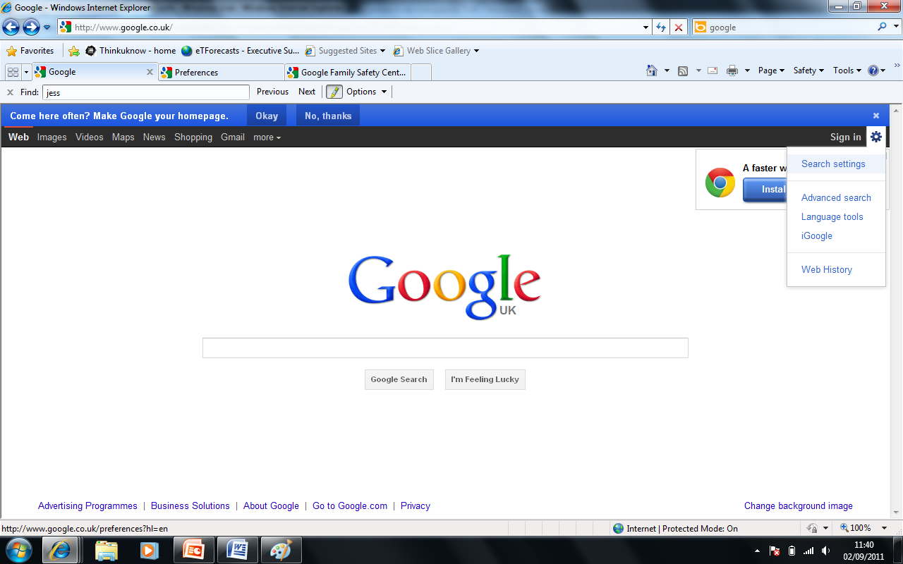
Scroll down the page and change the filtering options to suit your family’s needs. Make sure you lock the safe search; otherwise these settings can easily be changed without your knowledge.
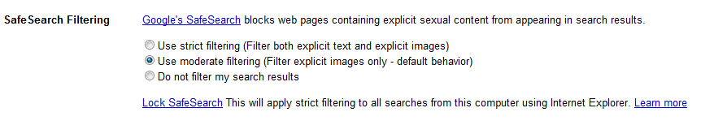
You can also set this on your child’s smart phone;
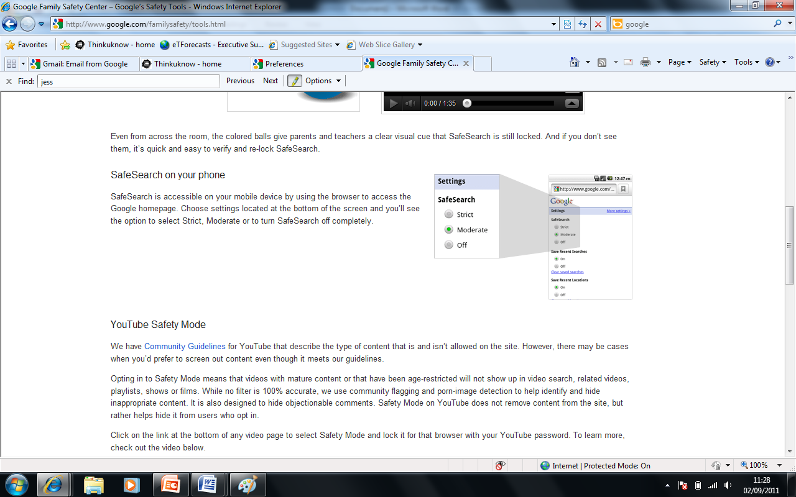
Please be aware that no filter is 100% accurate. We advise that you talk to your child about the sites they use. Why don’t you discuss:
- Their favourite online sites.
- What they enjoy most, the fun aspects of being online?
- What they think can go wrong?
- How would they react if things got out of control?
Let them know that you understand that situations happen online and that seeing ‘adult’ material can make them feel uncomfortable. Make sure they know that you are there to help.
Visit The Child Exploitation and Online Protection Centre (CEOP) parents’ information website for more information - www.thinkuknow.co.uk/parents
Mr King (E-safety Coordinator)
…………………………………………………………………………………………………………………………
We would like to a plan an e-safety awareness session for parents in the next few weeks. If you would be interested in learning more about e-safety in and out of school then please tick below. We would also like you to tell us what you would like in the session so that we can tailor it to your requirements.

I would be interested in an e-safety awareness session

I am not interested in an e-safety awareness session

Please specify what you would like to see in an e-safety awareness session.
……………………………………………………………………………………………………………………………
……………………………………………………………………………………………………………………………
……………………………………………………………………………………………………………………………
……………………………………………………………………………………………………………………………

