St Marys C of E Primary School

E-safety Reporting Tool- Whisper
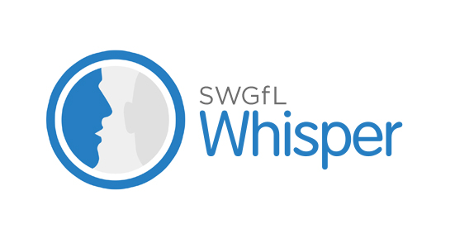

Dear Parent,

The safety and well-being of our pupils is something that our school takes extremely seriously. We continually work hard to provide ways to help you tell us if you or your children have any e-safety problems or worries which the School needs to know about.

Reporting issues is a very effective way to enable us to deal with risks before they escalate into harm, and we already have several ways in which you can report to our school. This helps us to maintain a safe and reliable environment for your children.

We understand that sometimes, coming into school to tell us about these issues cannot always be an easy thing to do. Time? Arranging an appointment? Speaking with staff? Sometimes it can be a subject that you need to bring to our attention without wanting to identify yourself, particularly if it involves children’s safety.

That’s why, we are continuing with Whisper on our school website, this year. Whisper is an anonymous reporting service for pupils, families and the local community that allows you to send a message or text to a confidential school email account where staff experienced in responding to issues will receive it.

How does it work?
Clicking on the Whisper button on our site will take you to an online form where you can leave your message. You can choose to send it anonymously or, if you want us to get back to you, you can leave your contact details. Whisper does not collect any information to identify a sender unless they choose to leave it.
You can also send a e-safety report to our school staff at : www.swgflwhisper.org.uk/report/stm5

You can also send an anonymous text by following the SMS instructions on our school website.
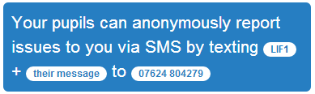
To send an anonymous text, text: STM5 +YOUR MESSAGE to 07860021584

Why do we think this is important?

This offers an anonymous route to empower individuals to report concerns.
We know that reporting can raise awareness of an issue across the school and things can change because of that, through discussion and education. Reporting someone who is bullying, for example, can very often focus attention on that person and is enough to change their behaviour. As always, alerting staff to issues early can address problems before they escalate. This fits in with our current practice.
Reporting bad behaviours can often stop them from happening to others. If people know their unacceptable behaviour will be reported they are less likely to do it.

What happens next?

We have been discussing Whisper with the children as part of our wider safeguarding education programme, plus how and when to use it. We hope it can provide a useful route for them to help safeguard themselves, their friends or the wider school community.

If you have any questions about the service then please contact Mr King or Mrs Tyreman or visit www.swgflwhisper.org.uk for more details about the service.

We are developing this initiative to contribute further to the positive safe school environment which we aspire to create for your child.

Thank you for your continuing support.

Many thanks

Mr King
E-Safety Coordinator

